Predicting Severity of US Car Accidents – A Machine Learning Approach

Business Problem

Auto insurance companies, public safety agencies, and state transportation departments face growing challenges due to increasing claims, operational disruptions, and budget constraints resulting from severe traffic accidents. Despite these pressures, their existing practices for assessing risks and allocating resources are primarily reactive and based on established rules, limiting their ability to effectively predict and mitigate the impact of accidents.
The core business challenge is to move from reactive response to proactive prevention and resource optimization by accurately predicting the likelihood and severity of accidents before they occur.

Background
Motorized vehicular transportation has dramatically transformed global mobility, shaping economies, urban landscapes, and social dynamics. However, this rapid growth of vehicle usage has also brought significant challenges, particularly in terms of road safety, corresponding rise in traffic accidents.
In 2024, early estimates from National Highway Traffic Safety Administration (NHTSA) indicate that 39,345 lives were lost in traffic accidents. Though this figure represents a reduction of approximately 3.8% from the 40,901 fatalities recorded in 2023, the number of fatalities still represents a staggering human toll and an economic loss exceeding $340 billion annually (in medical expenses, lost productivity, property damage, and emergency services).

Dataset

This project will use the dataset obtained from Kaggle comprising approximately 7.7 million unique car accident records with 46 features each, collected from February 2016 to March 2023 across 49 U.S. states (excluding Alaska). Sourced via multiple traffic APIs from U.S. and state transportation departments, law enforcement, traffic cameras, and road sensors, the dataset includes a unique identifier for each record to ensure validity. Its comprehensive nature enables machine learning models to detect key correlations—such as low visibility combined with roundabouts and nighttime conditions leading to higher severity—and supports robust predictive classification.
The Target Variable in this research is Severity, which represents the impact level of a car accident based on the disruption it causes to traffic. This outcome is crucial for predicting the overall consequences of accidents and informing safety measures. Temporal features capture the timing and duration of accidents, facilitating the analysis of patterns by various time dimensions such as start time, end time, sunrise/sunset, civil twilight, nautical twilight, and astronomical twilight. These features help identify trends related to the time of day, season, or lighting conditions at the time of the accident. Locational features provide geographic context, enabling spatial analysis across different settings, including city, county, state, and time zone. This grouping aids in understanding how geographical factors influence accident occurrences.
Environmental features describe conditions at or near the time of the accident and include temperature (F), wind chill (F), humidity, pressure (in), visibility (mi), wind speed (mph), precipitation (in), and weather condition (descriptive categories like clear, rain, snow, fog) critical for assessing the environmental factors that may contribute to accidents. Infrastructural features provide binary (True/False) indicators for nearby points of interest (POIs) or roadway attributes amenity, bump, crossing, give way, junction, no exit, railway, roundabout, station, stop, traffic calming, and traffic signal that could affect accident risk or severity.
Descriptive features consist of a free-text narrative of the accident, which serves primarily to provide context but can also be useful for natural language processing and feature extraction. This qualitative data contributes to a deeper understanding of the circumstances surrounding each incident, enhancing the analytical capabilities of the dataset.

Data Preprocessing
In the preprocessing phase of the data analysis presented in this white paper, a systematic approach was employed to ensure the integrity and usability of the dataset. Initially, checks were conducted to identify any duplicate records within the dataset. Subsequently, an evaluation of the class balance of the target variable, SEVERITY, was performed to ascertain if the dataset exhibited any significant imbalances that could skew further analysis.
Next, the volume of missing data across each feature was assessed to identify areas requiring intervention. Critical columns such as Description, City, Weather_Condition, Sunrise_Sunset, Civil_Twilight, Nautical_Twilight, and Astronomical_Twilight, along with temperature data, led to the deletion of records containing NaN values, ensuring the dataset's reliability. For features like Humidity (%), Pressure (in), Visibility (mi), Wind_Direction, Wind_Speed (mph), and Precipitation (in), the interpolation method was utilized to fill in missing values, preserving as many records as possible.
Afterward, any remaining records with NaN values were removed to maintain the dataset's robustness. For the Wind Chill feature, a scientific method was employed to estimate missing values more accurately. Following data cleaning, categorical data encoding was undertaken to convert qualitative information into a numerical format suitable for modeling. This involved standardizing the Weather Condition field by consolidating its categories, carrying out binning operations on various continuous features, and implementing binary encoding for multiple binary features such as Amenity, Bump, and Traffic_Signal. Additionally, ordinal encoding was performed for features with a natural order, including Sunrise_Sunset and various twilight conditions, while one-hot encoding was applied to the TimeZone and Weather Group features.
The preprocessing process also involved standardizing column names by converting them to uppercase and replacing symbols with underscores for consistency. Temporal features were transformed into timestamp formats, and new columns representing Year, Month, Day, Hour, Weekday, and Is Weekend were created through feature engineering efforts for both Start Time and End Time features. Less relevant columns were dropped to streamline the dataset, culminating in a focused selection of numerical columns deemed suitable for model building. This comprehensive preprocessing set the foundation for effective data analysis and predictive modeling.

Methods
A systematic end-to-end machine learning pipeline was applied, covering data preparation, exploratory analysis, modeling, and rigorous evaluation. The project follows established best practices in supervised classification, as the target variable (Severity) is ordinal/categorical with values typically ranging from 1 (least severe) to 4 (most severe).
Multiple predictive models were evaluated for car accident severity classification. On the imbalanced dataset, Logistic Regression achieved 79.67% accuracy (precision: 72.99%, recall: 79.67%, F1-score: 73.16%), with notable misclassifications across severity levels evident in the confusion matrix.
Random Forest, trained on approximately 50,000 records, slightly improved performance to 79.93% accuracy (precision: 74.33%, recall: 79.93%, F1-score: 75.03%), showing better class distribution and greater ability to capture data complexities.
Gradient Boosting delivered the strongest results, with 80.97% accuracy (precision: 77.00%, recall: 80.97%, F1-score: 74.67%). Its confusion matrix demonstrated superior handling of severity nuances, confirming ensemble boosting methods as particularly effective for this task.
Overall, each modeling approach contributed valuable insights, with Gradient Boosting outperforming the others in terms of accuracy and precision, underscoring the importance of selecting appropriate algorithms for the classification tasks at hand.
In the hyperparameter tuning phase of the model-building process, both Grid Search and Random Search techniques were employed to optimize the Random Forest model’s parameters, enhancing its predictive performance. The Grid Search evaluated a total of 12 fits across 4 candidates, identifying the best parameters as follows: criterion set to 'gini', max_depth at 10, max_features as 'sqrt', and n_estimators at 50. This configuration achieved a notable best score of approximately 0.807, reflecting the model's predictive capabilities.
The Random Search, which involved a broader search strategy with 200 fits across 40 candidates, yielded superior results. The best parameters discovered were n_estimators set to 300, max_features as 'sqrt', max_depth at 20, and criterion as 'gini'. This combination resulted in an even better score of approximately 0.809, further illustrating the effectiveness of the hyperparameter tuning process in refining model performance.
The outcomes from these tuning efforts highlight the critical importance of systematic parameter optimization in machine learning, demonstrating significant improvements in model accuracy and robustness through carefully selected hyperparameters.
Class Balancing
In the model building and evaluation phase, class balancing techniques were applied to ensure fair representation of all severity levels. The Logistic Regression model achieved moderate performance metrics: 66.52% accuracy, 65.53% precision, 66.52% recall, and an F1-score of 65.68%, with challenges in classifying different severity levels. In contrast, the Random Forest model excelled, reaching an accuracy of 93.51%, along with precision, recall, and F1-scores of 93.51%. Its confusion matrix showed mostly correct classifications. The Gradient Boosting model, while not as high-performing as Random Forest, had an accuracy of 76.71%, with precision at 76.40% and recall at 76.71%, indicating it struggled more with certain classes compared to Random Forest.
Overall, the results highlighted the importance of class balancing in enhancing model performance, particularly showcasing the Random Forest's superior capabilities in this context.
Analysis
In the exploratory data analysis performed for this project, a variety of visualizations were employed to uncover insights regarding car accidents. Some of the notable graphs includes, "Number of Car Accidents by Severity Across Years" illustrates the trend in accident frequency from 2016 to 2023, highlighting a significant spike in severe accidents in 2022, suggesting a potential increase in either the severity of incidents or reporting practices that year.
Another visualization, depicting "Accidents Distribution by Location," illustrated the geographical spread of accidents across different states, indicating areas with higher concentrations of incidents revealing revealed that states like California and Florida experienced the highest volume of accidents, represented in a bar chart titled "Top 10 States (Highest Volume of Accidents)," which quantified California's incidents at 22.53% of the total.
Further insight was provided through a density plot titled "Density of Accidents by Severity Across States." This graph depicted the distribution of accidents across different severity levels (1 to 4) within various states, revealing that the majority of accidents occurred at lower severity levels, with a notable concentration of accidents classified as severity level 1.
In the correlation analysis conducted, several factors were evaluated for their relationship with accident severity. The analysis revealed that the variable with the highest positive correlation to severity was the "DISTANCE_RANGE_CODE" (0.0568), followed by "WEATHER_RAIN" (0.0484) and "JUNCTION" (0.0440), indicating that these factors may have a slight association with more severe accidents.
Conversely, significant negative correlations were noted, particularly with "END_YEAR" (-0.2303) and "START_YEAR" (-0.2303), suggesting that accidents in more recent years tended to have lower severity ratings. Other notable negative correlations included elements such as "TRAFFIC_SIGNAL" (-0.1023) and "CROSSING" (-0.1045), pointing to a potential trend where controlled environments might reduce the severity of incidents.
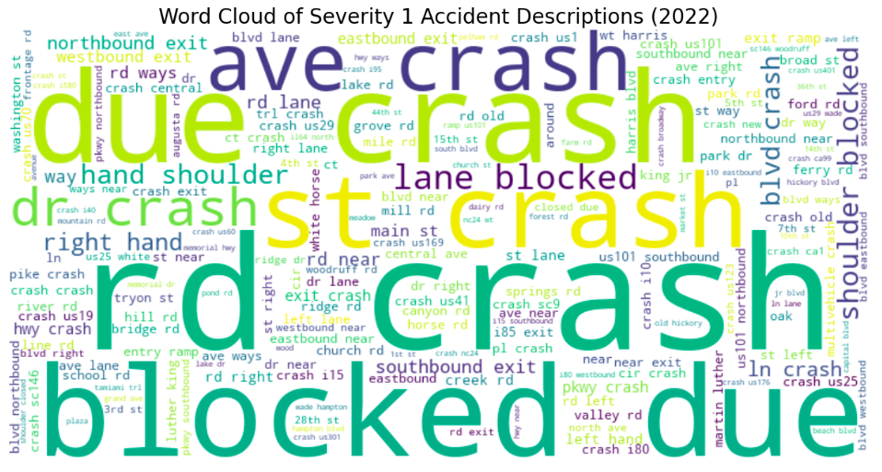 | 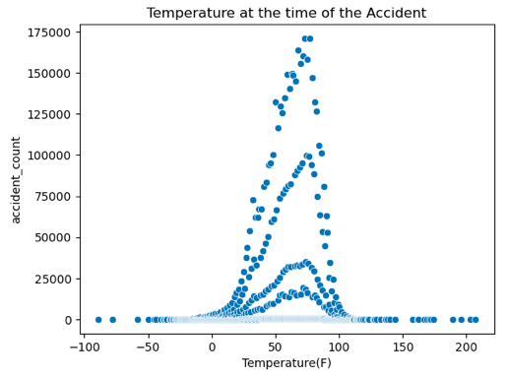
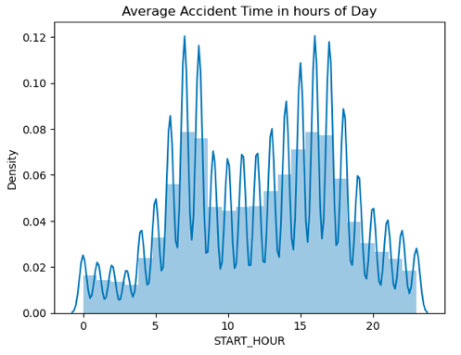 | 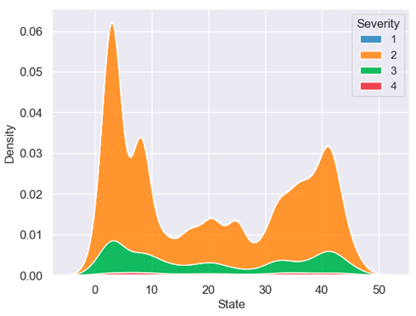
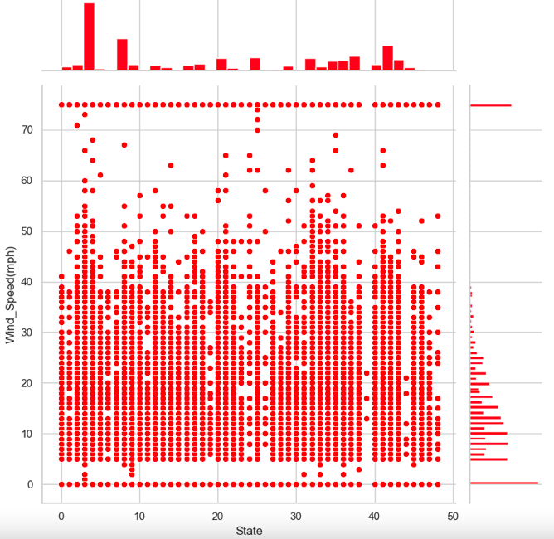 | 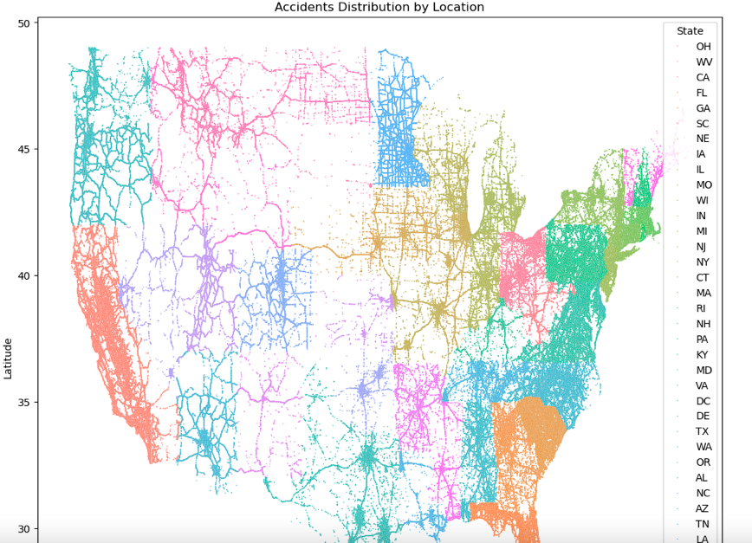

Conclusion
This comprehensive analysis of car accident data highlights the critical factors influencing accident severity, utilizing an extensive dataset with over 7.7 million records across 49 U.S. states. The project underscores the significance of various features, including temporal, locational, environmental, and infrastructural factors, and demonstrates systematic and effective data preprocessing to ensure data reliability.
Key findings reveal that while certain conditions, such as low visibility and proximity to junctions, correlate with increased accident severity, advancements in reporting practices may also contribute to observable trends over recent years. The modeling phase, employing logistic regression, random forest, and gradient boosting techniques, illustrates distinct performance metrics, with random forest emerging as the most reliable model, achieving accuracies upwards of 93% on balanced datasets.
Additionally, hyperparameter tuning significantly enhanced model performance, emphasizing the importance of model optimization in predictive analytics. Overall, this study provides valuable insights into the complexities of car accident severity and establishes a solid foundation for future research and safety interventions aimed at reducing accidents and improving traffic systems. Future work should focus on leveraging these insights for actionable policies and further refining predictive models through continuous data updates and integration.

Assumptions
This project relies on several key assumptions regarding the dataset and its attributes. The Kaggle-sourced US-Accidents dataset, encompassing approximately 7.7 million records from February 2016 to March 2023 across 49 states, is assumed to be comprehensive and sufficiently representative for robust statistical analysis and machine learning modeling, after considering the absence of data from Alaska.
Features are presumed to accurately reflect real-world conditions at the time of each incident, including environmental variables (e.g., weather, visibility) and infrastructural indicators (e.g., traffic signals, junctions). Finally, temporal features such as start time, end times, sunrise/sunset, and twilight indicators are assumed to reliably capture contextual patterns, meaningfully contributing to the identification of trends in accident occurrence and severity.
Limitations
This study acknowledges several limitations that may affect the interpretation and generalizability of its findings. The dataset excludes accident records from Alaska, potentially limiting the representativeness of results across all U.S. states and overlooking unique regional factors influencing severity. Additionally, the dataset lacks certain critical variables, such as detailed road surface conditions, direct indicators of driver impairment (e.g., DUI), or behavioral factors, constraining the models' ability to capture all relevant contributors to accident severity.
Lastly, even though the predictive models work well with the historical data, they might not be as effective for future accidents if new trends, such as advancements in vehicle technology, changes in traffic patterns, or shifts in climate conditions, differ from what is observed in this dataset.

Challenges

This project encountered several significant challenges that impacted the analysis and modeling process. The dataset's extreme class imbalance with Severity 2 comprising approximately 80% of records and Severity 4 cases only less than 3% posed a major obstacle, causing models trained on raw data to favor majority classes and exhibit poor recall for severe accidents despite reasonable overall accuracy. Computational constraints necessitated sampling for class balancing and model training, limiting the ability to leverage the full 7.7 million records. Finally, the absence of direct indicators for key risk factors such as driver impairment, detailed road conditions, vehicle-specific data constrained the models' explanatory power and predictive completeness.

Future Use
The predictive models developed in this project hold significant potential for real-world applications in enhancing road safety and operational efficiency. Integration into intelligent transportation systems could enable real-time severity forecasting, allowing emergency services to preposition resources, optimize dispatch priorities, and reduce response times for high-severity incidents. Insurers may incorporate these models into risk assessment frameworks for more granular premium pricing and fraud detection, while policymakers could use aggregated predictions to evaluate the effectiveness of safety campaigns or regulations.
Recommendation
To advance accident severity prediction and maximize practical impact, several targeted recommendations emerge from this study including prioritizing the adoption of ensemble models like Random Forest or Gradient Boosting (potentially augmented with XGBoost or LightGBM) in production environments, combined with robust class-balancing techniques such as SMOTE or class-weighted loss functions, to ensure reliable detection of rare severe and fatal incidents. Enhancing the Data Collection process by establishing live feed and exploring options to incorporating data for Alaska. Finally, ongoing model validation with post-2023 data is essential to adapt to evolving trends, such as increased electric vehicle adoption or autonomous driving features.
Implementation Plan
Successful deployment of the accident severity prediction models requires a structured, phased implementation plan to transition from research prototype to operational use. Phase 1: Model Finalization and Validation (1–3 months) – Select the top-performing model (Random Forest with tuned hyperparameters) and retrain it on the full preprocessed dataset, incorporating class weighting or stratified sampling to handle imbalance without excessive synthetic oversampling. Phase 2: Interpretability and Compliance (1–2 months) – Integrate explainability tools (SHAP or LIME) to generate feature importance rankings and individual prediction explanations. Phase 3: System Integration and Pilot Deployment (3–6 months) – Establish continuous monitoring pipelines to track model drift, prediction accuracy, and business impact (e.g., response time reductions). performance against live outcomes. Phase 4: Monitoring, Retraining, and Scaling (Ongoing) – Establish continuous monitoring pipelines to track model drift, prediction accuracy, and business impact (e.g., response time reductions).

Ethical Considerations
Data privacy is safeguarded despite the dataset's public nature and lack of explicit personal identifiers; rare re-identification risks from feature combinations are mitigated by aggregating or coarsening location data for public results and using free-text descriptions solely for feature extraction, without verbatim quotation in reports. Bias arising from historical reporting practices potentially influenced by geography, socioeconomic status, or race, leading to inconsistent severity scoring or under-reporting is countered through fairness assessments of model performance across states, urban/rural divides, and proxy demographics; detected biases will trigger post-processing adjustments and clear documentation of limitations.
Misuse risks, such as treating probabilistic predictions as definitive or applying them automatically to deny insurance claims, assign victim blame, or reduce emergency response in low-risk areas, are prevented by stating in all deliverables that outputs reflect statistical patterns only and require human oversight, without implying individual fault or inevitability. Transparency is maintained despite the lower interpretability of high-performing ensemble models all code, preprocessing steps, and model artifacts will be version-controlled and shared within data licensing constraints to enable independent auditing and reproducibility.

Important References
Primary Data Source
US Accidents (2016 - 2021). (n.d.). Www.kaggle.com. https://www.kaggle.com/datasets/sobhanmoosavi/us-accidents
Official Data Source
matthew.lynberg.ctr@dot.gov. (2018, August 23). NHTSA. NHTSA. https://www.nhtsa.gov/research-data
NHTSA. (2016, November 14). NHTSA. https://www.nhtsa.gov/research-data/fatality-analysis-reporting-system-fars
Technical Reference
Chen, T., & Guestrin, C. (2016). XGBoost: a Scalable Tree Boosting System. Proceedings of the 22nd ACM SIGKDD International Conference on Knowledge Discovery and Data Mining - KDD ’16, 1(1), 785–794. https://doi.org/10.1145/2939672.2939785

mariambayoumy. (2023, September 19). Us- analysis. Kaggle.com; Kaggle. https://www.kaggle.com/code/mariambayoumy/us-analysis
Ethical Consideration
Nihlén Fahlquist, J. (2009). Saving lives in road traffic—ethical aspects. Journal of Public Health, 17(6). https://doi.org/10.1007/s10389-009-0264-7
Responses to Anticipated Audience Questions
- What specific factors have you identified as the most predictive of accident severity?

Environmental factors like rain and low visibility, infrastructural elements such as junctions, and distance-related disruption indicators showed the strongest associations. Controlled features like traffic signals were negatively correlated with severity.

- How do you ensure the integrity and accuracy of the data used in your models?

Integrity and accuracy are ensured by conducting thorough checks for duplicates, evaluating class balance, and addressing missing data through specific imputation techniques and rigorous preprocessing.

- What machine learning algorithms did you consider, and why did you choose Gradient Boosting as the final model?

We considered several algorithms, including Logistic Regression and Random Forest; Gradient Boosting was chosen for its superior performance metrics and ability to handle the complexities of the data effectively. However, after class balancing, Random Forest significantly outperformed all models, achieving over 93% accuracy and better class-level recall.

- How do you address class imbalance in your dataset?

Class imbalance was addressed using techniques such as SMOTE and stratified sampling, ensuring that the model appropriately represented all severity levels during training.

- What are the primary limitations of your study, and how might they affect the results?

Key limitations include the exclusion of Alaska from the dataset and the absence of critical variables like driver impairment, which could constrain the models' predictive capabilities and generalizability.

- Can you elaborate on how environmental factors like weather and time of day influence accident severity?

Environmental factors such as low visibility and time of day significantly influence accident severity; for example, poor weather conditions and nighttime visibility are associated with higher accident rates and severity levels.

- What actionable insights or recommendations can public safety agencies derive from your findings?

Public safety agencies can use our findings to prioritize areas for safety interventions, optimize resource allocation during peak accident times, and design targeted awareness campaigns based on identified risk factors.
- What role does feature engineering play in improving your model's performance?

Feature engineering plays a crucial role by transforming raw data into meaningful features (hour, weekday, weekend) that enhance the model's ability to capture patterns and improve prediction accuracy.

- For deployment, predicting severity in real time would be valuable. How feasible is your best model (Random Forest) for real-time inference?

The Random Forest model is quite feasible for real-time inference, as it can be integrated into intelligent transportation systems to provide timely predictions while maintaining reasonable accuracy.

- If this model were to be used by emergency services or transportation departments, what would be the most important next steps?

Key next steps include model finalization and validation, implementation of interpretability tools for transparency, and continuous monitoring of model performance against live outcomes to adapt to evolving conditions.

